

GDMA Configuration and Installation Reference
(GroundWork Distributed Monitoring Agents V2.1)

Jan 25, 2010
Version 1.0

Prepared by:

Kevin Stone
Table of Contents
Summary 3
Configuration 3
Global Configuration Parameters 3
Per Service Configuration Parameters 9
Error and Status Messaging 10
Installation 11
Windows installation 11
Linux installation 11
GDMA switches 12
Figure 1 Poller Operation 13
Figure 2 Spooler Operation 14
Additional Information 15

Summary

This document describes the configuration details and installation methods for GDMA 2.1.

Configuration

In normal operation a GDMA host configuration is generated via the configuration tool Monarch using the “externals” capability. Global configuration parameters are set via a “host external” property and per service parameters are set via a “service external” property. See “Configuring Externals” in the bookshelf for details.

GDMA uses two configuration files to control its operation. These files share the same structure and command parameters.

Autoconfiguration Config
$basedir/config/gdma_auto.cfg is a component of the installation image and governs the behavior of the newly installed agent in an unconfigured state. The purpose of this file is to enable the agent to contact the master server and obtain a host configuration file without operator intervention. In general this file should not be modified unless special circumstances require non default auto configuration behavior. This file is also used to enable the agent to revert to autoconfiguration in the event that the host configuration file becomes corrupted or if the master server becomes unavailable.

Host Config
$basedir/config/gwmon_$host.cfg is normal mode configuration for the agent. This file overrides all parameters from the autoconfiguration file when it exists. This file will contain the global configuration and per service configuration details for the agent and the services to be monitored.

Global Configuration Parameters

Target_Server
Default Value = http://gdma_autohost
Valid Values = a valid http or https url
Used by Spooler: Yes
Used by Poller: Yes
Description: Defines system where agent will attempt to pull gwmon_$host.cfg file from. This may be in the form of a comma separated list to send results to multiple targets.

Target_Server_Secondary
Default Value =
Valid Values = a valid http or https url
Used by Spooler: Yes
Used by Poller: No
Description: Defines system where agent will attempt send check results when the Target_Server is unavailable.

GDMAConfigDir
Default Value = gdma
Valid Values = valid path string
Used by Spooler: No
Used by Poller: Yes
Description: Defines path where agent will attempt to pull gwmon_$host.cfg file from. This value is concatenated with Target_Server and the hostname of the target system to identify the configuration file to pull.

Example:
gdma_auto.cfg: Target_Server= “http://gdma_autohost”
gdma_auto.cfg: GDMAConfigDir=”gdma”
Target hostname=gdma_test

Would result in the agent pulling its configuration file from
http://gdma_autohost/gdma/gwmon_gdma_test.cfg

Enable_Auto
Default Value = on
Valid Values = on:off
Used by Spooler: Yes
Used by Poller: Yes
Description: Enables and disables auto configuration mode. This should normally be toggled on in gdma_auto.cfg and off in gwmon_$host.cfg

GDMA_Auto_Host
Default Value = gdma_autohost
Valid Values = string conforming to Groundwork/Nagios host object rules
Used by Spooler: Yes
Used by Poller: No
Description: Groundwork Host under which GDMA will submit auto configuration messages.

GDMA_Auto_Service
Default Value = gdma_auto
Valid Values = string conforming to Groundwork/Nagios service object rules
Used by Spooler: Yes
Used by Poller: No
Description: Groundwork Service under which GDMA will submit auto configuration messages.

Poller_Service
Default Value = gdma_poller
Valid Values = string conforming to Groundwork/Nagios service object rules
Used by Spooler: No
Used by Poller: Yes
Description: Groundwork Service under which GDMA will submit poller messages.

Spooler_Service
Default Value = gdma_spooller
Valid Values = string conforming to Groundwork/Nagios service object rules
Used by Spooler: Yes
Used by Poller: No
Description: Groundwork Service under which GDMA will submit spooller messages.

ConfigFile_Pull_Cycle
Default Value = 1
Acceptable Values = 1-10
Used by Spooler: No
Used by Poller: Yes
Description: Controls how often new configuration information should be pulled from the Master server, The value is a multiple of Poller_Proc_Interval.

ConfigPull_Timeout
Default Value = 10
Acceptable Values = 1-100
Used by Spooler: No
Used by Poller: Yes
Description: Controls how long in seconds to wait before timing out a configuration file pull attempt.
Enable_Local_Logging
Default Value = off
Acceptable Values = on:off
Used by Spooler: Yes
Used by Poller: Yes
Description: Enables local logging of events and errors. Default is off. If this is enabled some provision to clear or rotate logs should be employed.

Logdir
Default Value = /usr/local/groundwork/gdma/log/ or, for Windows GDMA: c:\program files\groundwork\gdma\log
Acceptable Values = absolute directory path
Used by Spooler: Yes
Used by Poller: Yes
Description: Path to write local log files. Must be valid absolute path and writable by agent user.

Poller_Proc_Interval
Default Value = 600
Acceptable Values = 60-900 seconds
Used by Spooler: No
Used by Poller: Yes
Description: Controls how often poller engine will run. Also used as a multiple by ConfigFile_Pull_Cycle and $SERVICE_Check_Interval. Modifying this value is not recommended without understanding the full impact on performance data collection and target system overhead for the environment.

Poller_Pull_Failure_Interval
Default Value = 86400 ( 1 Day)
Acceptable Values = 0- 2592000 seconds (0-30Days)
Used by Spooler: No
Used by Poller: Yes
Description: Controls how long poller will continue to operate in normal mode with the current host configuration after it can no longer pull a configuration file from the master server. When this timer expires the poller engine will remove the current host configuration file and revert to auto configuration mode. Setting this value to 0 disables this feature and the agent will continue to operate in normal mode with the stale configuration file indefinitely.

Poller_Plugin_Timeout
Default Value = 5
Acceptable Values = 0- 900 seconds
Used by Spooler: No
Used by Poller: Yes
Description: Controls how long poller will wait for a plugin to execute.

Poller_Plugin_Directory
Default Value = /usr/local/groundwork/gdma/libexec/ or, for Windows GDMA, c:\program files\groundwork\gdma\libexec
Acceptable Values = absolute directory path
Used by Spooler: No
Used by Poller: Yes
Description: Path to local plugins

Spooler_Batch_Size
Default Value = 20
Acceptable Values = integer > 5
Used by Spooler: Yes
Used by Poller: No
Description: Defines max NSCA batch size to use when transmitting results to master server.

Spooler_Max_Reties
Default Value = 10
Acceptable Values = integer > 1 and <100
Used by Spooler: Yes
Used by Poller: No
Description: Attempt transmission of results this many times before purging. Multiple of Spooler_Proc_Interval time.

Spooler_Retention_Time
Default Value = 900
Acceptable Values = positive integer and <900
Used by Spooler: Yes
Used by Poller: No
Description: Unsent spooled results older than this number of seconds will be purged.

Spooler_NSCA_Port
Default Value = 5667
Acceptable Values = valid tcp port number
Used by Spooler: Yes
Used by Poller: No
Description: Port to use when transmitting spooled results.

Spooler_NSCA_Timout
Default Value = 5
Acceptable Values = 1-30 seconds
Used by Spooler: Yes
Used by Poller: No
Description: NSCA send timeout

Spooler_Proc_Interval
Default Value = 180
Acceptable Values = 60-900 seconds
Used by Spooler: Yes
Used by Poller: No
Description: Controls how often spooler engine will run. Also used as a multiple by Spooler_Max_Reties.

Spooler_NSCA_Program
Default Value = /usr/local/groundwork/gdma/bin/send_nsca.pl
or
c:\program files\groundwork\gdma\bin\send_nsca.pl
Acceptable Values = absolute path to send nsca program
Used by Spooler: Yes
Used by Poller: No
Description: Location of send nsca program

GDMA_Multihost
Default Value = off
Acceptable Values = on:off
Used by Spooler: No
Used by Poller: Yes
Description: Enable Multihost (windows child) behavior See Windows Child How to for details

Per Service Configuration Parameters

check_(service)_Enable
Default Value = on
Acceptable Values = on:off
Used by Spooler: No
Used by Poller: Yes
Description: Enable or disable service check

check_(service)_Service
Default Value = n/a
Acceptable Values = string conforming to Groundwork/Nagios service object rules
Used by Spooler: No
Used by Poller: Yes
Description: Groundwork/Nagios service name

check_(service)_Command
Default Value = n/a
Acceptable Values = command definition to be executed by poller
Used by Spooler: No
Used by Poller: Yes
Description: Command definition

check_(service)_Timeout
Default Value = 5
Acceptable Values = 0- 900 seconds
Used by Spooler: No
Used by Poller: Yes
Description: Controls how long poller will wait for a plugin to execute.

Error and Status Messaging
Unless configured with Enable_Local_Logging = on GDMA will not produce any log output on the target system. Normal messaging is returned to the master system via the standard spooling and NSCA transmission methods.

Service | Type of Message | Description | Example
gdma_auto | missing configuration | Indicates unconfigured GDMA host or corrupt configuration file | “gdma_autohost;gdma_auto;3;No configuration file: my_host [192.168.5.13] running MSWin32 5.00”
gdma_spooler | startup message | Indicates normal startup | “my_host;gdma_spooler;0;Spool processor 1.0 started at Wednesday January 6 16:55:27 2010”
 | status message | Indicates normal operation | “my_host;gdma_spooler;0;Spooler transmitted 11 results in 0 secs”
 | transmission failure | Indicates that spooler failed in transmitting results | “my_host;gdma_spooler;2;Failed to transmit 1 results to 192.168.5.74”
 | purge message | Indicates that results are being expired from the spool | “my_host;gdma_spooler;1;Retention timer 900 reached for 38 messages, messages purged”

gdma_poller | status message | Indicates normal operation | “my_host;gdma_poller;0;OK Poller processed 9 checks in 8.547 secs Using 1.42% of 600 sec Polling Interval”
 | startup message | Indicates normal startup | “my_host;gdma_poller;0;Poller 1.0 started at Wednesday January 6 17:01:08 2010”
 | config change | message Indicates that a configuration change has been detected. | “my_host;gdma_poller;1;Configuration change detected :C:\groundwork\gdma\config\gwmon_my_host.cfg at Wednesday January 6 16:13:06 2010”

Installation

Windows installation

- Download GDMA installer to the target system
- Run the installer
- Select Next, Next, Finish

The installer will
- install GDMA in c:\program_files\groundwork
- create the GDMA service.
- Set the GDMA service for auto start
- Start the GDMA Service

Linux installation

- Download GDMA installer to the target system
- Make installer executable
- Run the installer
- Accept or modify default Target Server [gdma_autohost]:
- Accept auto start default
- Continue

The installer will
- install GDMA in /usr/local/groundwork
- install init script in /etc/init.d
- set /etc/init.d/gdma to start automatically
- Start the GDMA Service

GDMA switches
gdma_poll and gdma_spool_processor provide the following switches for troubleshooting. These should not be used in normal operation.

Poller Switches

#/usr/local/groundwork/perl/bin/perl gdma_poll.pl -h

GDMA poller agent for version 1.0 monitors system statistics on this server.
Dumps the results to spool file.

Options:
-c <CONFIG FILE> Config file containing monitoring parameters.
-a <AUTOCONF FILE> File with default settings. Must contain a target server address.
-l <LOG DIR> Full path for log directory for this script
-d <1,2> Debug mode. Will log additional messages to the log file, 1 less 2 most.
-h Displays help message.
-x Run once. If this option not selected, run continually with sleep.
-i Run interactively - shows output to the cli (non service mode) as well as to log
-v Show version.

Spooler Switches

/usr/local/groundwork/perl/bin/perl gdma_spool_processor.pl -h

GDMA Spool Processor version 1.0 monitors system statistics on this server.
Results are sent back to the GroundWork server(s) using NSCA.

Options:
-c <CONFIG FILE> Config file containing monitoring parameters.
-a <AUTOCONF FILE> File with default settings. Must contain a target server address.
-l <LOG DIR> Log directory for this script, relative to GDMA HOME.
-d <1,2> Debug mode. Will log additional messages to the log file, 1 less 2 most.
-h Displays help message.
-x Run once. If this option not selected, run continually with sleep.
-i Run interactively - shows output to the cli (non service mode) as well as to log
-v Show version.
Figure 1 Poller Operation
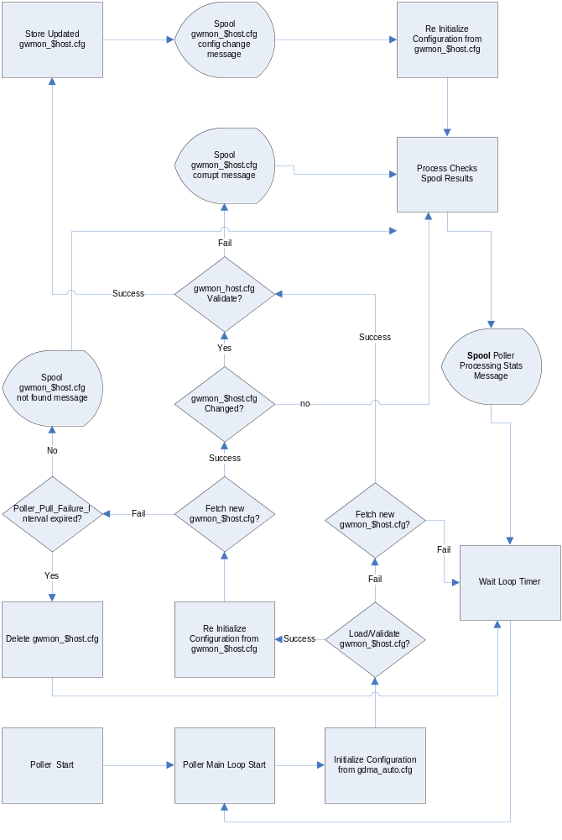
Figure 2 Spooler Operation
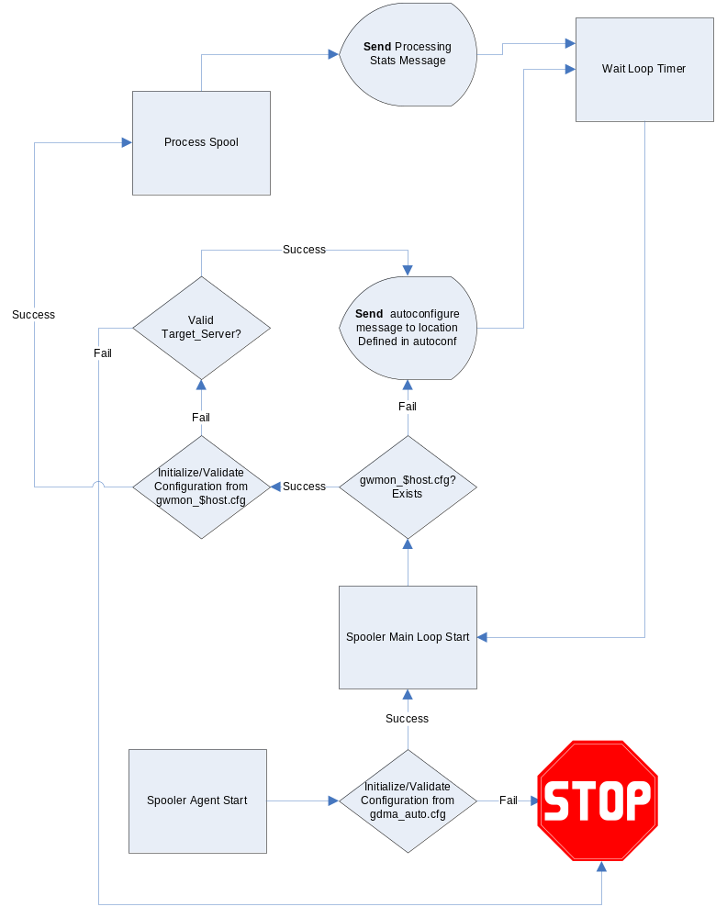
Additional Information
GDMA Master Server Configuration Howto
GDMA Linux Target Configuration Howto
GDMA Windows Target Configuration Howto

